Grainger Trust – Project Scope
- Identify GT units:
  - DMR marker
  - specific tenancy templates – DMR, affordable rent
  - Maintain the maximum number of residents allowed per GT unit. TBD
- Customize the leasing journey for Grainger Trust.
  - Exclude marketing-related steps; only start once the local authority has identified the new customer
  - Questionnaire - TBD
  - Reference upfront – TBD
    - Grainger reviewing the current referencing process and determine if Home Let can replace Reference My Tenant for Grainger Trust applications
  - Viewing – capture more details - TBD
  - Post Viewing
    - Create contact account
    - Create price book entry (agreed price)
    - Create offer
    - Validate the maximum number of residents allowed per unit. TBD
    - No offer sent
  - Move in Monies: Send payment link to tenant 5 days prior to move in
    - Enter basic details
    - Send chaser emails
    - Generate Grainger Trust-specific emails (template)
    - Excludes payments - TBD
  - Signing: Send tenancy agreement & supporting docs (once tenant pays deposit)
    - Generate Grainger Trust-specific documents (1 template)
    - Tenant signs via Adobe Sign.
  - Audit: Move to Audit for credit control to add tenant to Qube – TBD
  - Close: Send welcome email & attach to opportunity
- Data migration from spreadsheets (exported from Qube that only include GT tenants not already in Salesforce).
  - Create account & contact records.
  - Create tenancy records (excludes opportunity records - TBD)

Current Salesforce Process:
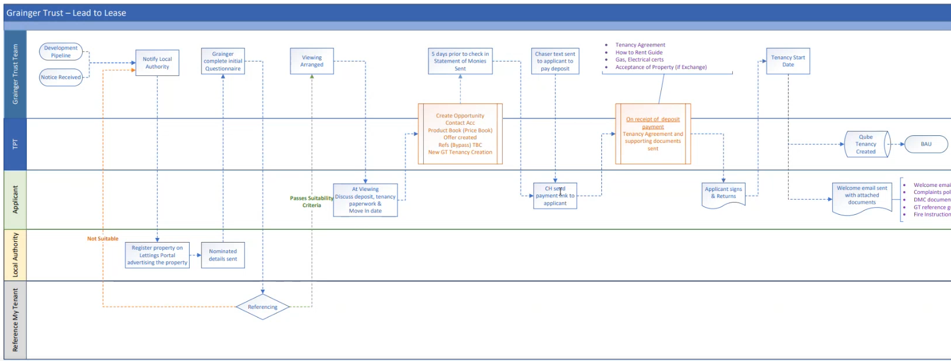

Out of scope:
- Additional KYC data points for Grainger Trust tenants, residents and shared owners.
  - Security to limit access to sensitive KYC data to the appropriate Grainger personnel.
  - KYC data migration from 1 spreadsheet
  - Require the upfront capture of KYC data.
- User guide

